Assignment -4

TEAM ID : PNT2022TMID50454

PROJECT NAME : NUTRITION ASSISTANT APPLICATION ROLL NO: P.POOJA (952419104022)

N.THILAGAVATHI (952419104036)

N.SIVATHARANI (952419104033)

T.MAHA RAJA (952419104016)

Question-1:

pull an image from docker hub and run it in docker playground. pull an image form docker hub

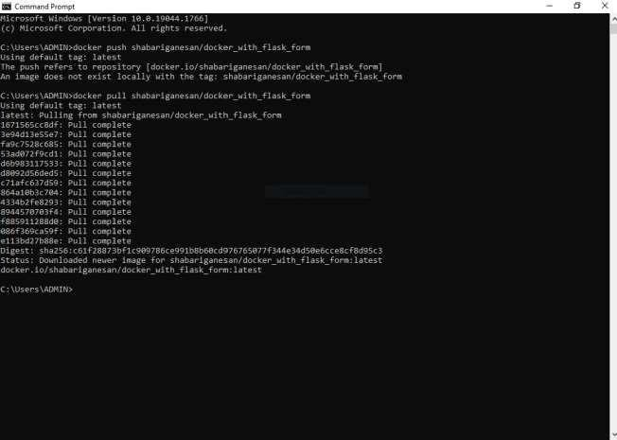

run it in docker playground

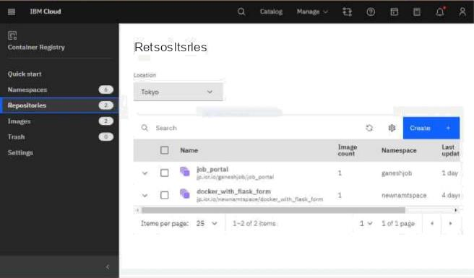

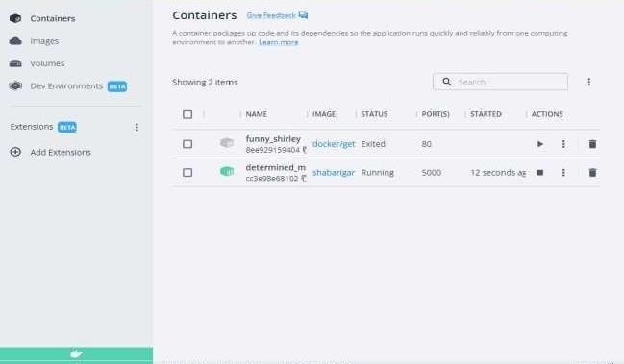

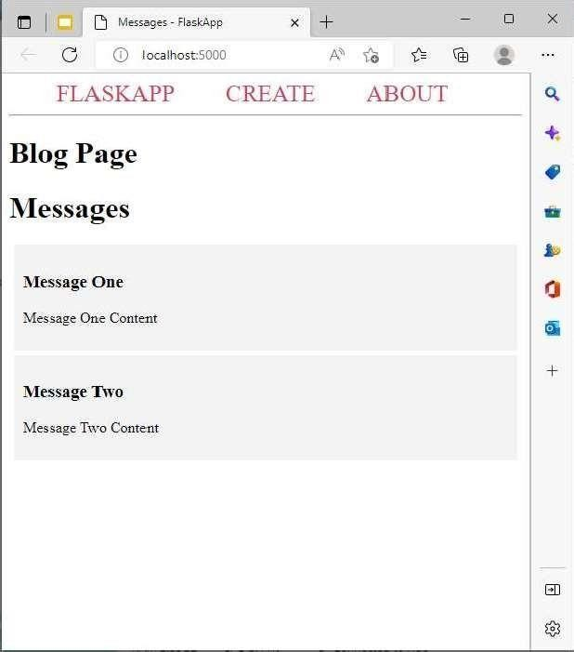

Question-2:

Create a docker file for the jobportal application and deploy it in docker application.

Creating a docker file for the jobportal application

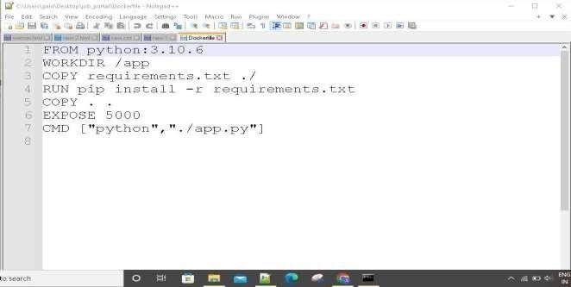

deploy in in dokcer application

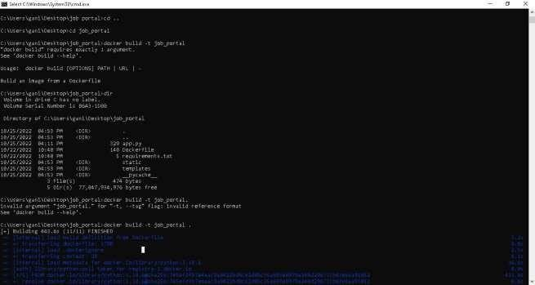

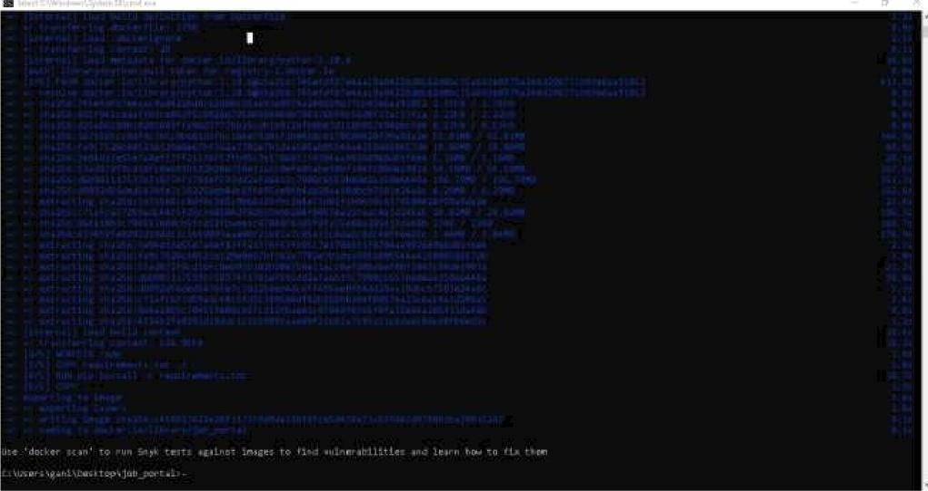



C c rat ¿z i n e r S



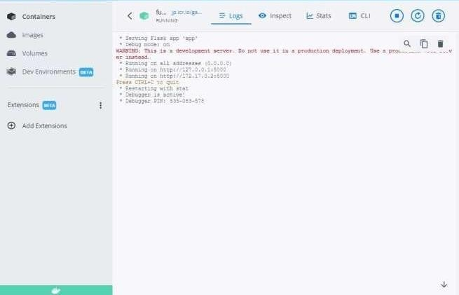



**running in docker desktop 1**

Question-3:Create aIbm container registry and deploy helloworld app or jobportalapp create a ibm container registry



deployhelloworld or jobportal

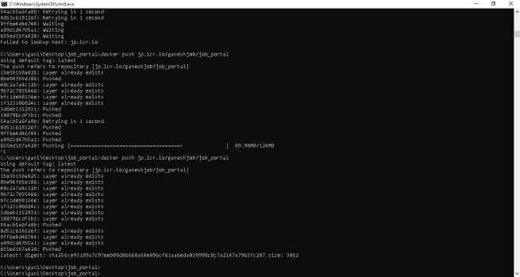



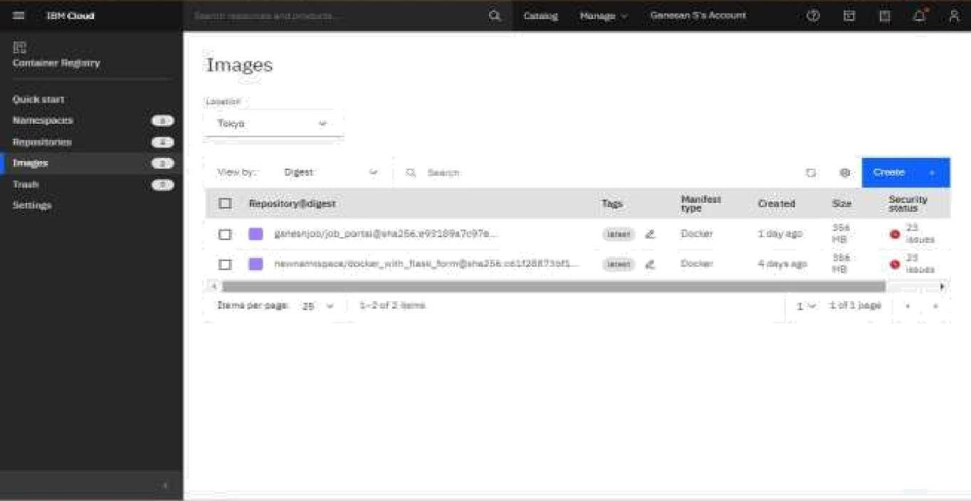

Question-4: Create a kubernetes cluster in ibm cloud and deploy helloworld image or jobportal image and also expose the same app to run in noteport

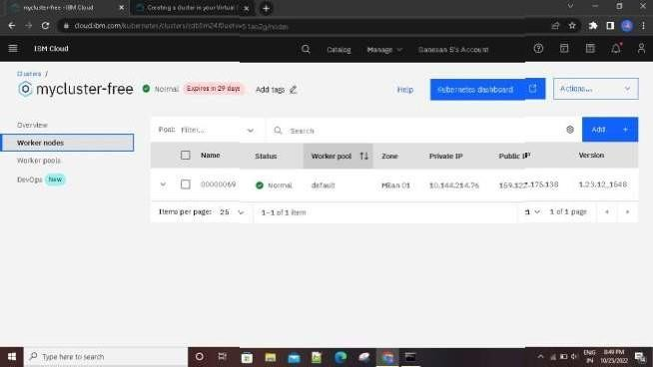Creating a kubernetes cluster in ibm cloud

**deploy helloworld image or jobportal image and also expose the same app to run in noteport**

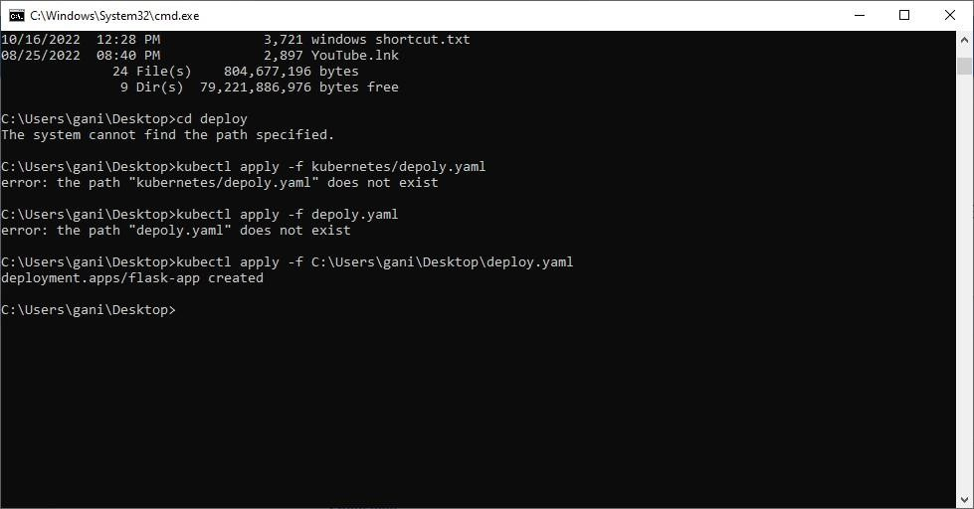











Wa1lin-g for more da la a display c har l... Wa li ng for more data a di splay chart...







